

# Programming Web/Cloud/Mobile

# # Lab Assignment 2

**Team Members:** Pragathi Thammaneni Sri Devi Mallipudi

LAB Assignment-2

# Introduction:

This Lab assignment deals with the basic web technologies HTML, CSS, JavaScript with responsive web design (RWD), AngularJS. In this lab assignment it primarily focuses on the basic topics of Web Programming.

# Objectives:

To code for the 2 questions by implementing the below concepts**.**

* HTML CSS, JavaScript
* AngularJS
* Responsive web design

# Approaches /Methods:

Using HTM5, CSS3, Bootstrap, JavaScript, AngularJS, YouTube Data API and WebStorm

# Workflow &Datasets/Parameters and Evaluation:

The below each question will follow different approaches to solve. Coding is done to perform the evaluation of each individual snippet to build Tic-Tac-Toe game and web application using YouTube Data API.

# Question 1:

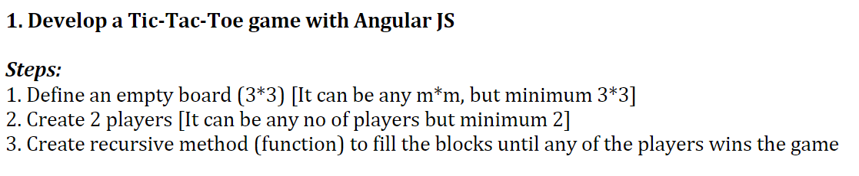

**Solution:**

Home Page:

Below is the screenshot of the home page Tic-Tac-Toe game, it contains a button to start a new game. Two players X and O can play alternatively by marking the boxes, the player who marks three boxes vertically, horizontally or diagonally wins the game.

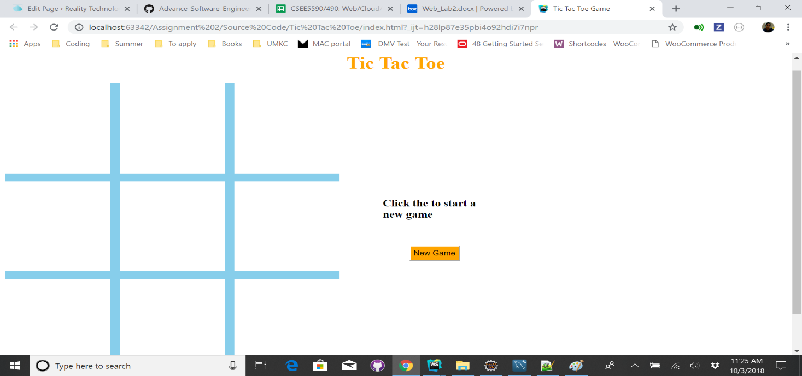

After a player marks a box a message will be displayed about the next player turn to make a move.

#### C:\Users\devim\Documents\GitHub\Programming-web-cloud-mobile\Assignments\Assignment 2\Documentation\Tic Tac Toe -2.png

#### C:\Users\devim\Documents\GitHub\Programming-web-cloud-mobile\Assignments\Assignment 2\Documentation\Tic Tac Toe -3.png

#### 

If a player succeeds in marking the three of the boxes in a vertical, horizontal or diagonal row then a message will be displayed saying respected player wins.

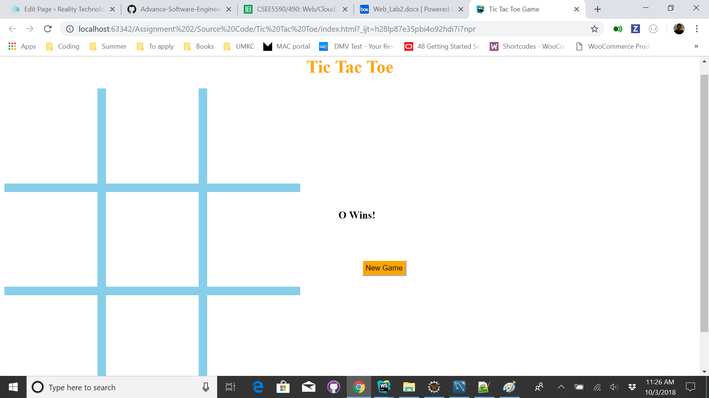

**Question 2:**

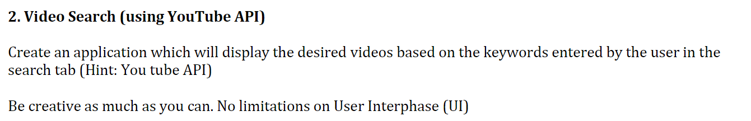

**YouTube data API** – lets to search the trending videos with a search keyword. Whenever user gives a keyword then the response results includes the top results related to that keyword.

**Home Page:**

In home page there is a label to enter search keyword of video user is interested in and then click search button.

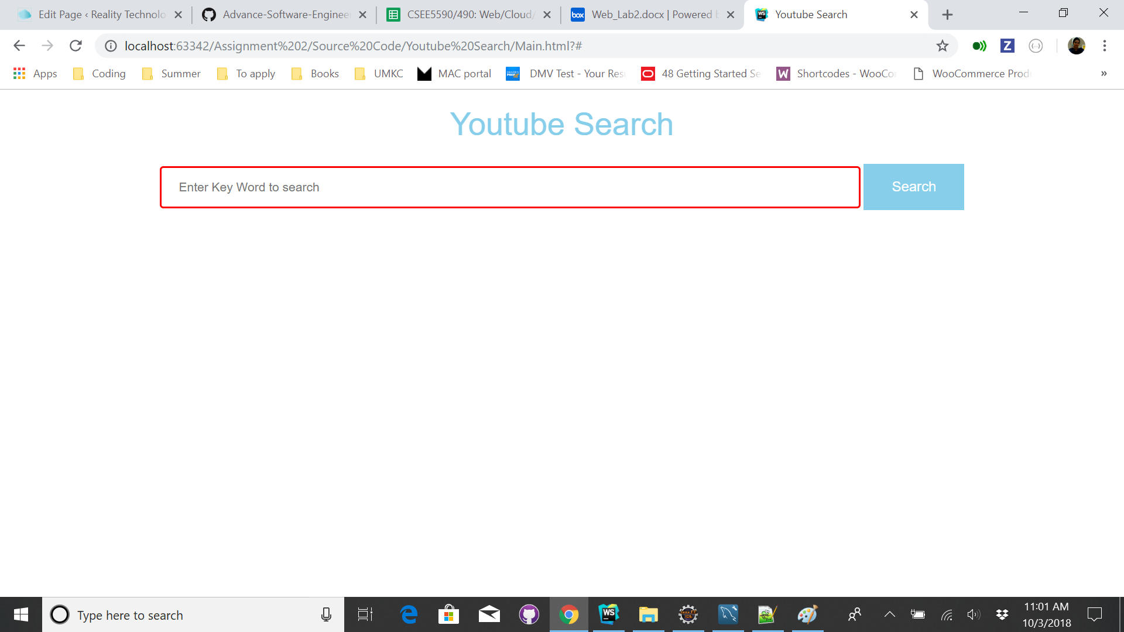

Then the keyword information is sent to the YouTube Data API which checks the videos that are related to search keyword using search.list() method and returns the top 10 trending videos.  The response contains the name of the video with the adjusted frame size of the video.

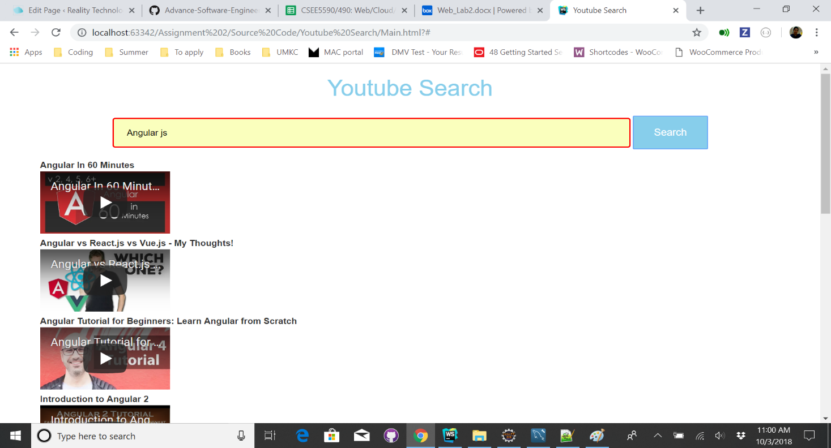

Below is the sample response for the search keyword “love” that contains the array of top 10 tending videos with the video links.

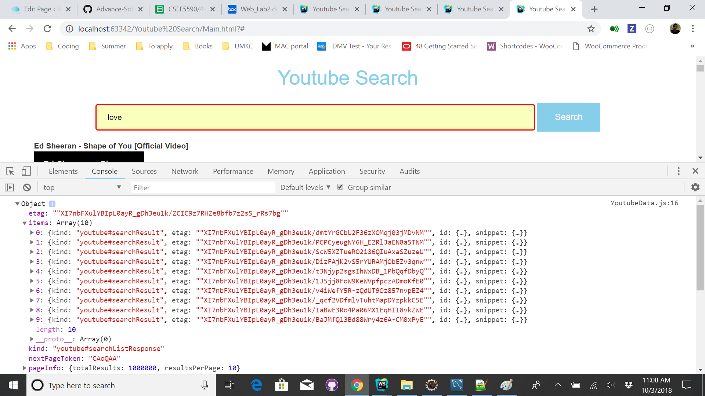

**Conclusion:**

As stated the above workflow with certain set of parameters is followed in solving the execution by implementing the core and basic concepts of the web programming.

# Source code link: <https://github.com/Sridevi333/Programming-web-cloud-mobile/tree/master/Assignments/Assignment%202>

**Video Link: <https://youtu.be/WsJozIqWLb8>**

# Wiki Link:

<https://github.com/Sridevi333/Programming-web-cloud-mobile/wiki/Lab-Assignment-2>